Kingdom of Saudi Aribia Qassim University Collage of Computer



2

0

SOFTWARE DESIGN **2**

DESCRIPTION FOR **3**

**STUDY**

**GROUP**

**Prepared by**

Shahad Jamaan Alzhrani Lina Khaled Alhumaidi Jawaher Obead Almoqati Joori Abdullah Alsaif

1. **Introduction**
   1. **Document purpose:**

This document specifies the architecture of the system and application design of our project ( GroupStudy app),

Which is an app that allows student to have the opportunity to join or create a study group in a subject they have difficulty in understanding, allowing them to better communicate with each other and to improve their grades.

In the following sections, it specifies the requirements of the system in respect to the audience.

### Scope :

This software design document is being developed for the ( Group Study App ) project, Which is an app that allows student to have the opportunity to join or create a study group in a subject they have difficulty in understanding, allowing them to better communicate with each other and to improve their grades**.**

### References :

I.CS383 lecture notes.

* 1. **Document Overview: 1.5 Overview**



The Software Design Document is divided into 7 sections with various subsections. The sections of the Software Design Document are:

1. **Introduction**
2. **System overview**
3. **process model**
4. **Data Design**
5. **Detailed Design**
6. **Use Case**
7. **UI Overview**

**1**

## System Overview

For a first time user:

First, the user is asked to enter their information ( name, password, email),

After that the user as asked to allow the app to get their location in order for the app to work properly, then the user is asked to pick their topics of interests. Based on the information the user entered ( location and favorite topics) the user will have a suggested groups on the home page if a group exist with a similar information.

Then the user has the choice of joining the suggested groups or create a group of their own choice. The user will be able to access the chat, their profile and get reminder notification for their groups.

And in this document we have provided a detailed information about the app’s architecture and design using UML diagrams for more clarification.

## process model

We have chosen a waterfall process model because, we are aiming for a clear structure for our app with high security Since the requirements that the app offers are limited , fixed and there is no room for unexpected changes.

## Data Design

#### Database Description

The database of our app stores the user’s information which consists of: user name, user id, User email, user password, user’s location, user names of the user is friend with (following), groups and topics the user is affiliated with.

And it stores the groups information: the group’s name, Id , topic, location, time,

state (public or private), maximum number of members and the id’s or usernames of the members.

It also stores the user’s chat history and as for topics, each topic has a name and an id to make sure that they’re unique.

# 2

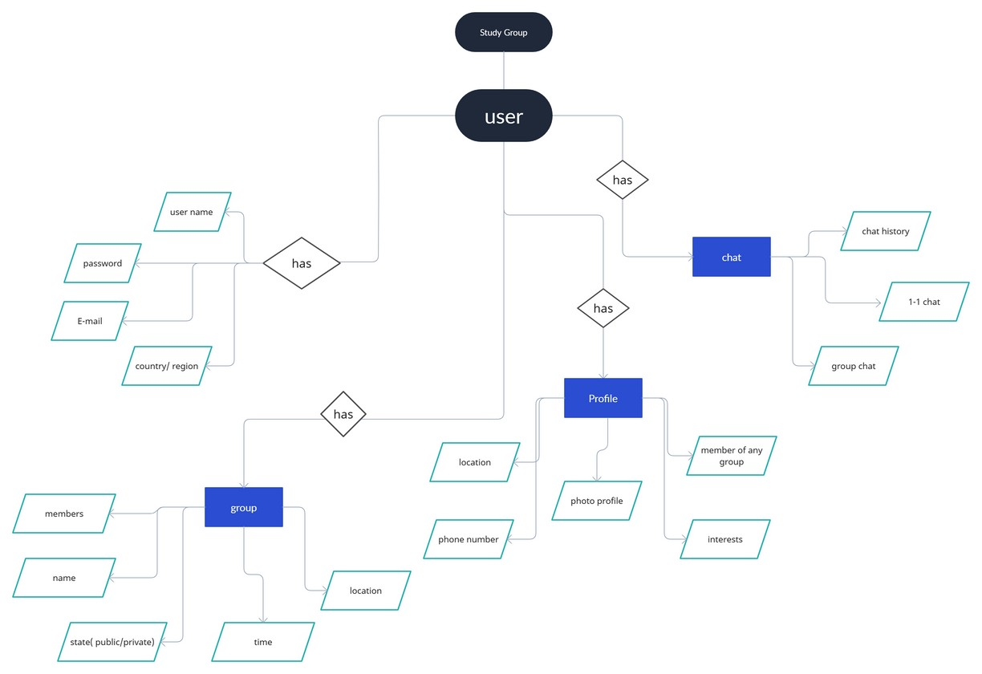

### Data Flow Diagram:

**Context Diagram:**

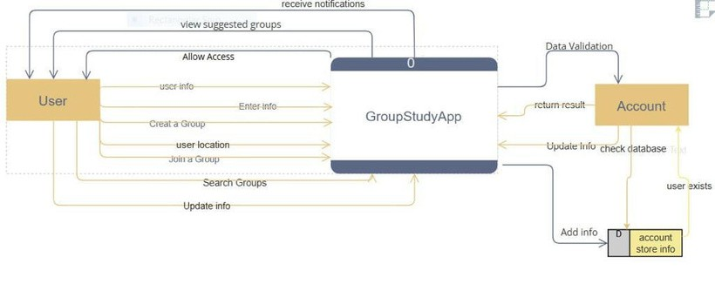

**3**

**Level 0:**



**4**

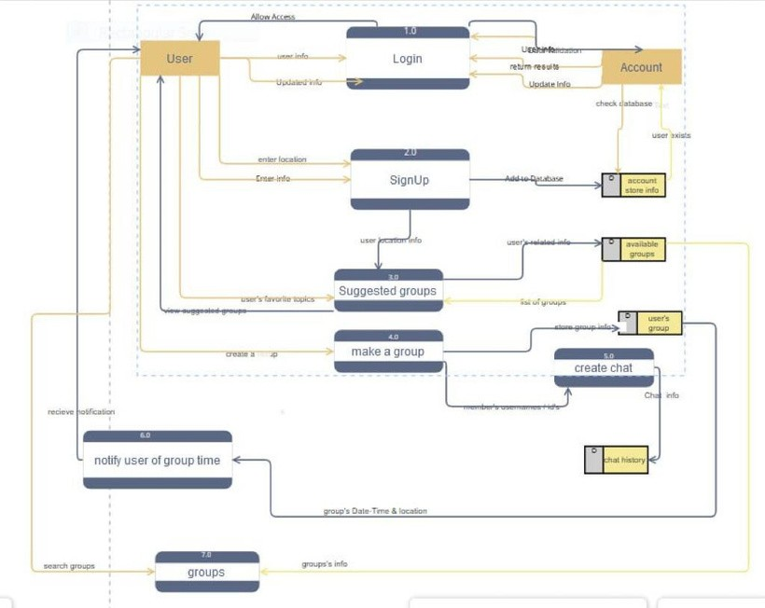

1. **Design Details**
   1. **Class Diagram:**

# 5

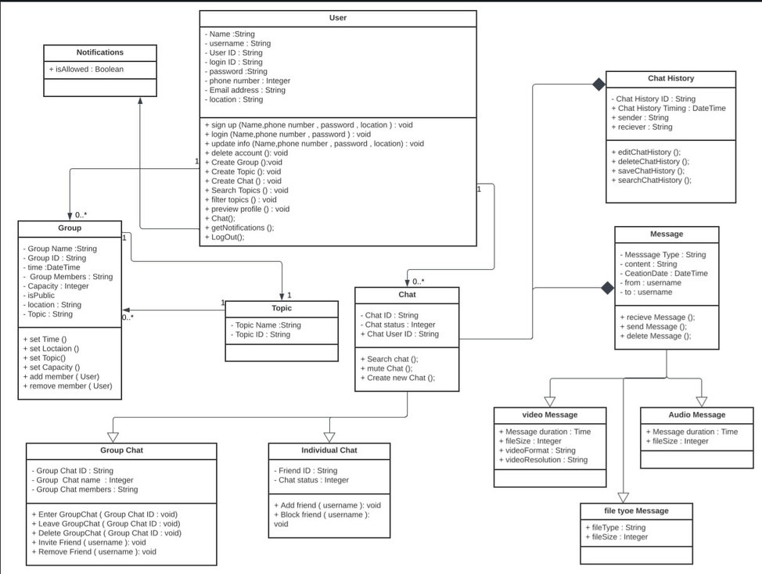

#### Activity Diagram:

LOG IN SIGN UP

Find account?

Y E S

HOME

N O

LOCATION

YOUR INTEREST

CHAT

MAK GROUP

MY

ACCOUNT NOTIFICATION TOPICS

MALAK EL HALAI B

GROPS

It’s private?

Y E S N O

SEND REQUEST

JOIN



# 6

#### State Diagram:

open/enter the app ---, •



*_)*

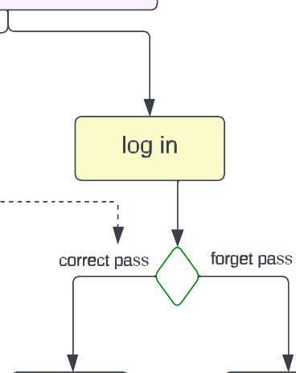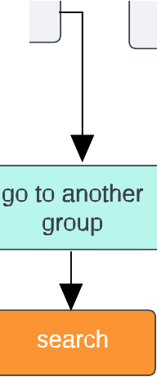

-··-··-··-··- 1

upload app until internet  **internet unconnect**

comes

**internet connect**

log/sgin in page

home page

choose topics

l

yes no

log in the app

new pass

exisit group

make new group

yes

no

,--

**can send photo/voice /files?**

enter

can enter members

profile

not edit edit

member

**E:i+++M**

r-y_e_s 'I

no

Ill

save privous changes

changing the profile

L

complete all information in profile

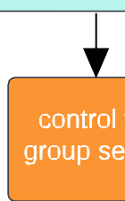

# 7

#### Sequence Diagram:

WELCOME PAGE UI(LOGIN,SIGN

LOCATION

HOME PAGE

GROUP

NOTIFICATIONS

DATABASE

*SIGN UP*



*PASS DATA*

*GET LOCATION*

*LOGIN*

*PASS*

*LOCATION*

SAVE DAT A

***ALTERNATIVE***

*I F THE USER EXIST*

*I F THE*

*USER NOT EXIST*

*SET LOGGED IN*

*ERROR MESSAGE*

*VALID DATA*

*INVALID DATA*

*CHECK LOG IN DATA*

*SEARCH DATABASE*

CH OOSE T OP I C

T OP I C L I ST

*TOPICS & LOCATION*

*SHOW SUGGESTED GROUPS*

*SEND NOTIFICATION*



**8**

*JOIN A GROUP*

SAVE GR OU P

1. 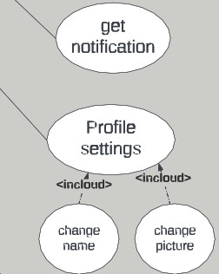**Use Case**

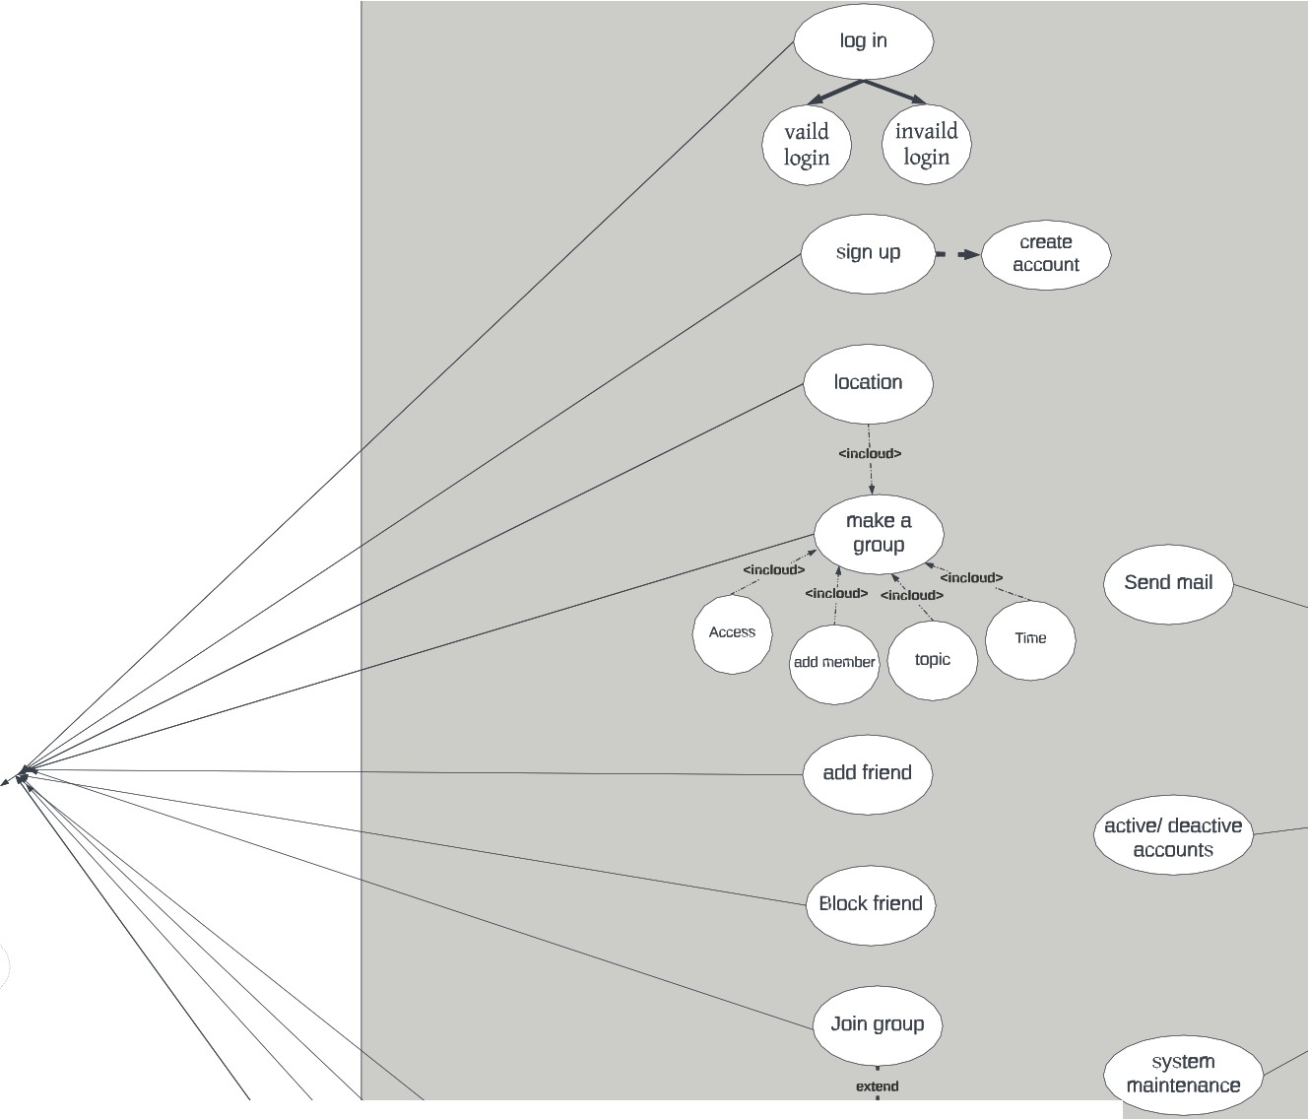

8

User



Admin

send request

# 9

1. **user Interface Overview**

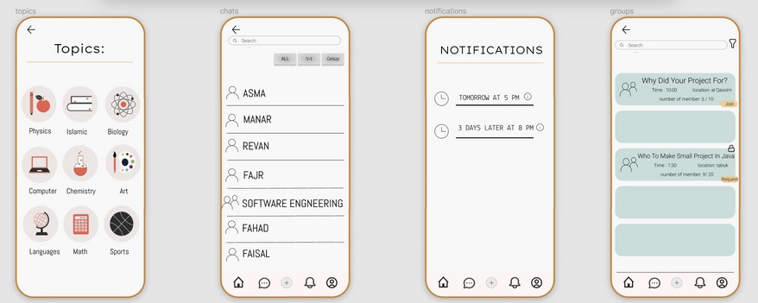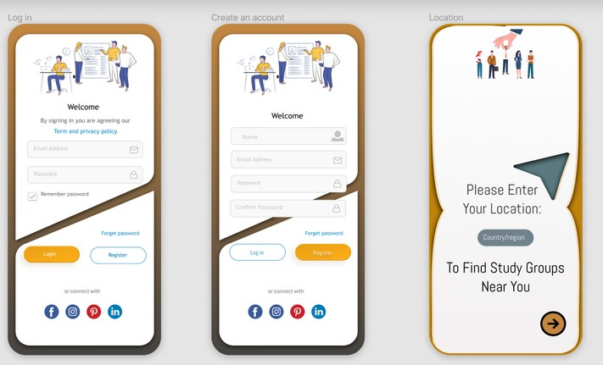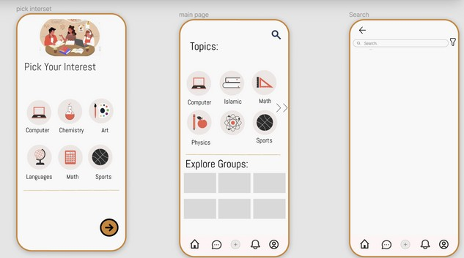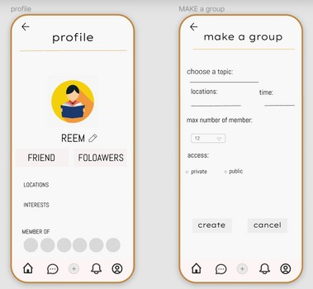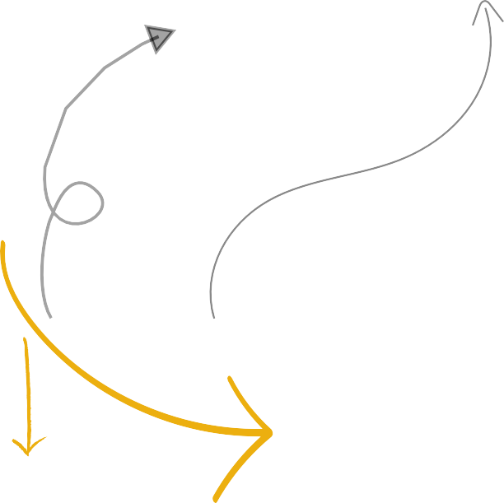

-Scan for live Preview :

**10**



**11**